

אוניברסיטת בן-גוריון בנגב

Ben-Gurion University of the Negev

הפקולטה למדעי ההנדסה

המחלקה להנדסת חשמל ומחשבים

Faculty of Engineering Science

Dept. of Electrical and Computer Engineering

פרויקט הנדסי שנה ד'

Fourth Year Engineering Project

**Executive Summary**

[Brain tumor segmentation using deep learning](http://projects.ee.bgu.ac.il/zf/public/projects/projinfo/id/s-2018-104)

סגמנטציה של גידולים מוחיים באמצעות למידה עמוקה

|  |  |  |
| --- | --- | --- |
| מספר הפרויקט: | p-2018-049 | Project number: |

|  |  |  |
| --- | --- | --- |
| סטודנטים  (שם ו ת.ז.): | Roy Hirsch 305052920  302724893 Ori Chayoot | Students  (name & ID): |

|  |  |  |
| --- | --- | --- |
| מנחים: | Dr. Tammy Riklin Raviv | Supervisors: |

|  |  |  |
| --- | --- | --- |
| תאריך הגשה: | 2017 | Submission date: |

1. **Introduction:**

In this document we will introduce **AutoSegment** an advanced AI algorithm for brain tumor segmentation.

1. **Market opportunity:**

Glioma is a type of brain tumor originated from the Glial cells. Glioma tumor is the most common type of brain cancer and represent 24.7% of all primary brain tumors[1].

3D MRI scans are used for prediction and evaluation of the tumor progress, before and during treatment. Glioma tumors differ by shape, localization and size. Therefore, segmenting the tumor region is a complicated mission. Nowadays, most of the segmentation process is done manually by experts. The manual segmentation process is expensive, long and may be inefficient. We aspire to change this manual segmentation process by introducing a new robust, precise and automatic segmentation algorithm.

The market:

Nearly 80,000 of new cases of primary brain tumors are expected to be diagnosed every year in the U.S. There are nearly 700,000 people in the U.S. living with a primary brain and central nervous system tumor.[2]

Our system’s potential customers are hospitals and in particular imaging and radiology departments. Our system will be implemented and will help doctors to analyze more efficiently MRI brain scans.

The global vascular imaging market is expected to reach USD 5.95 Billion by 2022 from USD 4.35 Billion in 2017. The market is segmented into MRI, CT, ultrasound, nuclear imaging, and X-ray imaging. 7. See fig [1] for the compound annual growth rate (CAGR) per market.[3]

In particular, the global magnetic resonance imaging market is projected to rise from a valuation of US$6,611.0 Mn in 2017 to reach US$9,120.8 Mn by end of 2022.[4] Geographically, North America is the leading market with estimated revenue share of US$3,212.1 Mn by 2022 end.

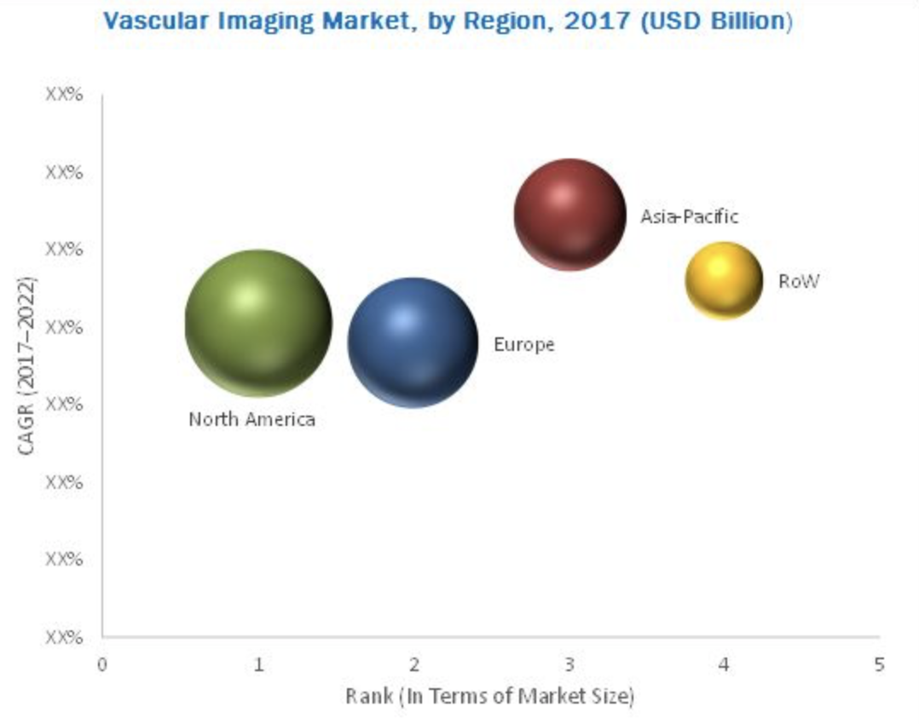

1. **Product and technology:**

**AutoSegment** is an advanced, AI based brain tumor segmentation system. Our system consists of:

* User interface: for visualization of 3D MR images and segmentations.
* Backend algorithm: based on state-of-the art AI neural network. Our algorithm is robust, fast and efficient. A deep convolutional neural network that was trained on verity of brain MRI scans is the heart of the algorithm. This deep learning architecture ensures that the algorithm is efficient and capable of segmenting tumor regions precisely.

1. **Business model:**

Our business model is based on subscriptions. Our potential customers are hospitals that will pay for the software services of our product. For a fixed price we will implement our off-the-shelf system at the customer’s site and will provide software implementation and updates. For additional payment we will provide customization of our system to the client’s needs.

1. **Competition and Differentiation**

Medical imaging competitors’ products:

OsiriX – a world famous medical images viewer.[5]

syngo.via – by Siemens is a medical imaging software solution. The software offers semi-automated 3D lesion segmentation[6].

IntelliSpace Portal 8.0 – by Philips, offer tumor tracking and segmentation[7].

Those products are mainly MRI imaging softwares with some additional features of segmentation. Some of the offered segmentation solutions are semi-automatic. We offer a system that is fully automated and focused on segmentation. We believe that our fully automated solution will be distinguish and innovative in compare to the competitors’ solutions.

Open source brain analysis tools:

Software packages like: [CamBA](https://en.wikipedia.org/wiki/Cambridge_Brain_Analysis), brainsuite[8], [Mango](https://en.wikipedia.org/wiki/Mango_(software)).

Those open source project are mainly used by researches and are not conflict with our potential market.

1. **Go-to-Market Strategy:**

As a first step, we intend to market our product to the North America market, as the leading market by our market research. Then, we intend to market our system to the Europe market as the second biggest market. After establishing in those markets we will be available to scale into smaller markets.

1. **Current Status**

Currently we are on the conceptual research stage of our product. We intend to deliver alpha version in three months. The company in also during recruitment session, to establish our R&D team. Currently we are looking for a seed investment of one million USD.

1. **The team:**

* Ori Chayoot - CTO and founder, expertise in applied physics and neural network’s based products. Last year student for BSC in Electrical engineering, former officer at unit 8200.
* Roy Hirsch - CEO and founder, expertise in product management. Last year student for BSC in Electrical engineering, former officer at unit 8200.

1. E. C. Holland, "Progenitor cells and glioma formation", Curr. Opin. Neurol., vol. 14
2. http://www.abta.org/about-us/news/brain-tumor-statistics
3. https://www.transparencymarketresearch.com/pressrelease/magnetic-resonance-imaging-market.htm
4. https://www.marketsandmarkets.com/Market-Reports/vascular-imaging-market-247188200.html
5. <http://www.osirix-viewer.com/osirix/osirix-md/osirix-9-0-release/>
6. <https://usa.healthcare.siemens.com/medical-imaging-it/clinical-imaging-applications/syngovia/features>
7. https://www.usa.philips.com/healthcare/product/HC881062/intellispace-portal-80-all-your-advanced-analysis-needs-one-comprehensive-solution
8. <http://brainsuite.org>